Best Practices and Standards for Creating Monarch Tactile Graphics
  - A Handbook for Educators and Transcribers

Introduction
The Monarch presents a unique opportunity for students and their teachers, parents, and peers to engage with conceptual learning and academic performance at an enhanced level. When combined with traditional methods of tactile production – embossing, tooling, incorporation of 3-D manipulatives, and collage – use of the Monarch provides dynamic access to tactile graphics that is highly motivating, enriching, and empowering. This brief handbook is similarly conceived as a dynamic platform for engaging with our expert trainers, teachers, transcribers, and other visual impairment specialists in developing and communicating best practices for Monarch-based tactile graphics.

Tactile Graphic Drawing Programs
Graphic drawing programs that can create vector graphics and save them as compatible files (i.e., PDF, JPG, PNG, BMP) are suitable for creating tactile images for the Monarch. Some of the most popular and useful programs currently available include:
- Adobe Illustrator and Photoshop
- CorelDraw
- Microsoft Word and PowerPoint
- TactileView
- Canva
- Inkscape
Software programs such that save documents as print-only (PRN) files are also powerful graphics drawing and embossing tools, but they are incompatible with the Monarch.

File types
The Monarch’s Tactile Viewer will accept files saved in PDF, JPG, PNG, and BMP formats. PDF files appear in the Tactile Viewer with two zoom levels, providing an overview where the full graphic is fit to the Monarch display at 100%. JPG, PNG, and BMP appear with additional zoom levels. However, JPG, PNG, and BMP are image-only file types and do not support the inclusion of braille. PDF is necessary if your graphic will include braille labels or text, because this file type differentiates between text and image, rather than rendering all information as pixels. The tactile results of JPG, PNG, and BMP files may also be less reliable than those of PDF files.

Braille Fonts
- Preferred font: Braille29 (29-point or 24-point) is fully supported using the Monarch’s Tactile Viewer
  - Braille29 Font
- Additional fonts may be used, though their tactile results may vary. For example: commonly used braille fonts Swell Braille and Duxbury Braille will display at a font size of 24 points, but they may not display as well as Braille29.

Definitions: Elements in Graphics
- Area: Significant region in a graphic
  - States or provinces in a map, stripes of different colors in a flag, layers of soil or rock in a classification diagram
- Line: Linear information
  - Rivers, geographic boundaries, historical routes, pathways in an electrical circuit, outline of a shape, parts of an angle, length to be measured
- Point: Specific place on a graphic
  - Location of a city, bus stop, oil well, point in a line graph, gland in an anatomy diagram
- Label: Words or alphabetic or numeric key used to identify an area, line, or point symbol
Source: Guidelines and Standards for Tactile Graphics, 2022, Braille Authority of North America

Basic Considerations and Principles of Graphic Design
- What are the key components you will be reproducing and how do you want to create them?
  - Areas, lines, points, and labels (including necessary keys or legends)
- Eliminate unnecessary parts
  - As a general rule, automatically omit anything that is decorative
  - For complicated graphics, determine what is needed to convey meaning and what is extraneous
- Simplify as much as possible
  - Many print graphics can be altered effectively to better fit a tactile format without altering the meaning
  - Example: Simple shapes can be used for counting purposes in mathematical diagrams rather than more complex print images
- Separate a cluttered, complicated image that needs to retain most of its parts into multiple graphics for better discrimination and understanding
- When possible, 3-D print images should be rendered in 2-D tactile graphic form with an explanation to the reader
- Be consistent with your use of symbols and keys
- Place the graphic at the left margin of the page
- Include a blank line before and after the graphic
- Make graphics as small as is reasonable for their individual requirements and your student’s needs, while still leaving enough space around and inside them for exploration and recognition
  - Especially when small hands are looking at them!
- Diagrams in which the reader is asked to measure or compare measured areas should be produced as close to the original size and scale as possible while still maintaining the integrity and original intent of the print graphics
  - Note: Diagrams produced in Word may have slightly different dimensions and measurable results when they are rendered on the Monarch's digital tactile display, so some accommodation should be provided for students who are completing classroom assignments or tests using graphics with measurement tools on the Monarch
- Avoid clutter
  - Simplicity and ease of access are key to Monarch graphic-reading success

Spacing
- Keep your delineations between elements (lines, areas, points, etc.) as clean and discriminate as possible
- Separate objects should be spaced at least one braille cell apart to ensure they can be easily distinguished by the reader
  - The center of your fingertip should fit between any two graphic elements so that you can feel a small but clear distance between them
  - Use blank space or different line textures to distinguish between overlapping elements
- Don't put labels too close to or too far away from the elements they identify
  - A good rule to follow is to leave at least ¼ inch of blank space between any graphic element and labels or related text
  - The same “center of your fingertip” guideline applies here
- To create distinct lines and shapes in a complex graphic, use different textures or leave at least 1/8 inch of blank space around a line, area, or point
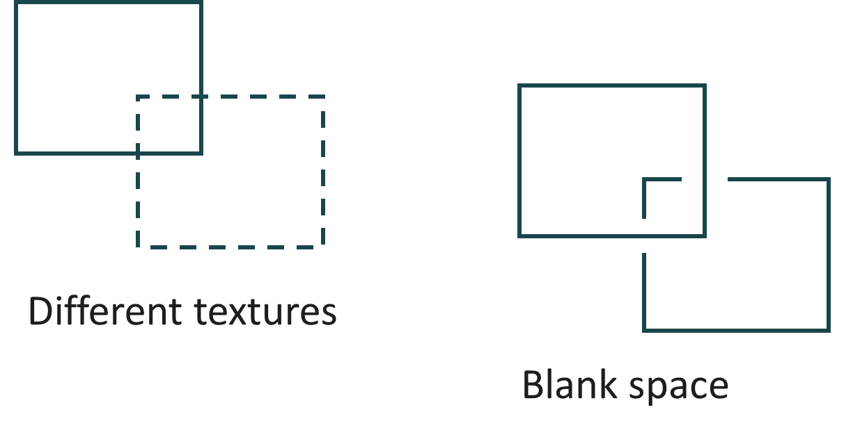
- Retain a margin of at least ½ inch around your entire graphic, so that it does not coincide with or overlap the edge of the Monarch’s screen.
The Monarch interprets images as pixels, and during the translation process from software to hardware some precision may be lost. It is important to review your work on the Monarch device and make necessary adjustments before presenting it to a student. Elements in your graphics that you may want to pay particular attention to are dotted and dashed lines, areas with fine textures and details, intersections of lines or shapes, and places where tiny details meet, such as at the point of a small star. New updates will continue to improve each facet of the device, including its interaction with graphics software programs.

Line weights
- Lines between 2 and 5 points display consistently on the Monarch as a single row of pins. However, there may be some variation based on where the line is located (i.e., if it falls “between” pins) and if it is vertical, horizontal, diagonal, curved, etc.
- To increase the thickness of a line, the general rule of thumb is to increase the line weight in increments of 5. For example, a 10-point line typically displays as two rows of pins, a 15-point line displays as three rows of pins, etc.
- It is highly recommended that you test these various types of lines and their different line weights with simple drawings that employ a variety of shapes and lines to gain an in-depth understanding of their applications and uses. Continued checking and testing is also recommended as you create your drawings, as the Monarch is continually being improved and updated.
- Note: The lines shown below were created using CorelDraw.

A few notes to assist you when creating lines and choosing line weights or other features:
- Use only black lines
- Dashed and dotted lines can be used for contrast, but it will be necessary to experiment to find the weight(s) that are best for the graphic you are creating
- The “More Detail” filter (dots 46 + enter) might need to be used to view lines that are too thin
As you create your drawings and test them on the Monarch, APH welcomes your feedback and input. Please use the email address outreach@aph.org to send us your comments, suggestions, and discoveries that may be beneficial for sharing with other professionals.

Color
- Solid black lines and text should be used to ensure legibility on the Monarch.
- Generally, any value greater than 80% black will display in Tactile Viewer’s default settings.
- Values lower than 40% black will not display in Tactile Viewer’s default setting but might appear once the “More Detail” filter is applied.

Size
- The Monarch can display images of many sizes, but it is best to keep tactile graphics between 3.5″ by 8″ and 11″ by 11.5″
  - Ensure that the size of a graphic image is manageable, so that exploration does not require excessive panning and unnecessarily complex mental assembly of image details
  - Graphics should be just large enough for all parts to be accurately discriminated and read using the Monarch's Zoom feature, allowing sufficient space to accommodate and properly associate braille labels with their representative parts
  - A maximum space of 11″ by 11.5″ also ensures that a graphic can be embossed, if desired, on standard-sized braille paper
  - Working within a canvas or drawing space of 4″ by 8″ is ideal

Textures
- The Monarch displays a single level of pins, so there will be some differences between how graphic textures are displayed with embossers that have multi-level capabilities and how these textures are rendered on the Monarch
- Textures with fine detail, such as the “snow dots” texture fill, may not translate to the Monarch as conceived in the drawing software
- The larger the details of a texture, the better it will appear on the Monarch
  - “Brick” patterns and checkerboards with ¼-inch squares have proven to be discernible
  - Line and checkerboard patterns tend to be successful on both the Monarch and the PixBlaster
  - Horizontal, vertical, and diagonal lines spaced at least 3/16-inch apart show up well
- While smaller sizes may also appear in limited detail, they may have missing dots/textures or parts that are not satisfactorily distinct
- Some graphic details intended for Monarch display may benefit from simplification or representation in ways other than using multiple textures
- It is important that you review your graphics on the Monarch before presenting them to a student. Remember that although a graphic may "look" good, it might not "feel" good. Ongoing experimentation with student feedback will be a great benefit to you in finding the right patterns for your Monarch graphics.
Included on the following page is a series of patterns that appear on the Monarch and are tactually recognizable. These Monarch-friendly patterns were created in CorelDraw, but their features are relevant to other software drawing programs. As always, we encourage you to experiment freely with pre-programmed patterns whatever software program you prefer. Remember, textures may look very different on the Monarch than they do on the visual screen or with an embosser!

Conclusion
We hope this guide has provided you with the information you need to confidently apply proven standards, best practices, and methods to the unique needs and capabilities of the Monarch’s Tactile Viewer. We welcome your feedback, questions, and suggestions, and encourage you to share with us the results of your trials and experiments with Monarch graphics creation. Please contact us at outreach@aph.org.

