Draw with Word for the Monarch
Contents
Draw with Word for the Monarch 1
Introduction 2
Font for Braille Labels 2
Important Resource 3
Braille Translation Programs 4
Caution! 4
Drawing with Word 4
Insert Ribbon 4
Shapes Tool 5
Shape Format Tab 7
Shape Styles 7
Shape Styles: Shape Fill 8
Shape Fill → Pattern Fill 9
Shape Outline → Weight 10
Shape Height and Width 11
Arrows 11
Icons 12
Comments Regarding the Use of Icons and Other Prefabricated Images 14
Other Types of Images 14
Text Wrapping 15
Grouping Objects 15
Using the MS Word Graphic Template 15
Blank Space 16
Elements That Cross: Examples 16
Braille Labels 17
Braille Labels: Uncontracted 17
Braille Labels: Contracted 17
ASCII Examples 18
Using the Apostrophe and Quote Keys 19
Creating Text Boxes for Braille Labels 19
Text Boxes with White Fill 21
Hints for Using ASCII in Braille Labels 21
Braille Text Copied from a Translation Program 21
Saving Your Graphic Document 22
Guidelines and Standards for Tactile Graphics 23
Elements in Graphics 23
Basic Design Principles 24
Keys 25
Conclusion 26

Introduction
Using Microsoft Word to draw graphics has many advantages for teachers and specialists who provide individualized instruction to students with visual impairments. Unlike other drawing programs that must be purchased at significant cost and installed by an IT team for use only by transcribers, Word is often conveniently available on teacher laptops and can be used to create graphics in real time, with students present to explore and provide rapid feedback on the results. Although more robust and fully graphics-dedicated software programs may allow a user to create graphics with more consistent, advanced, and professionally designed qualities, Word is an excellent “on-the-go" option for teachers, parents, and students to use in the classroom or at home for many daily academic and recreational tasks. Combined with proven traditional graphics production methods, including embossing, tooling, use of 3-D manipulatives, and collage, Word paired with the Monarch provides a needed element of convenience and ease of access that offers students multiple diverse options and enhanced opportunities for success.

Font for Braille Labels
You will need a simbraille font to create tactile graphic labels with Word. Currently, Braille29 is the best simbraille option to use with the Monarch. You can download Braille29 at https://tactilegraphics.cs.washington.edu/comp-architecture/. Once downloaded, open the file and activate the “Install” button. Use a font size of 29-point with Braille29.

Important Resource
The following resource provides valuable guidance on tactile graphics creation:
Guidelines and Standards for Tactile Graphics, 2022 (brailleauthority.org)
See especially:
- Decision Tree, §1.8, page 1-2
- Appendix A, “Braille to ASCII Conversion,” page A-1

Braille Translation Programs
You may prefer to use a braille translation program if you want to add full sentences or paragraphs of braille text for reference to your tactile graphic. The following translation programs are free and conveniently downloadable:
- BrailleBlaster, by American Printing House for the Blind
- Sao Mai Braille, by Sai Mai Center
You can also use any commercial software, such as Duxbury or Braille2000. For free six-key entry software programs:
- Braille Zephyr, by American Printing House for the Blind
- Perky Duck, by Duxbury Systems

Caution!
This guide is based on Microsoft Word 365 for Windows 10/11. You may be using a different version of Word or operating system (or both) and Word 365 receives continual updates which may change this workflow. While the steps in the process may differ slightly for you, and some features/elements described here may be missing or located elsewhere, the overall concept should be the same from one version to the next and may simply require a little imaginative negotiation from you. If you are having significant difficulty with your version of Word or its interaction with your operating system as you go through the steps in this guide, please contact APH at outreach@aph.org for assistance.

Drawing with Word
The steps that follow will guide you through creating graphics with Word.

Insert Ribbon
Click on the Insert ribbon to display a basic menu of drawing options.
Keystroke: Alt + N
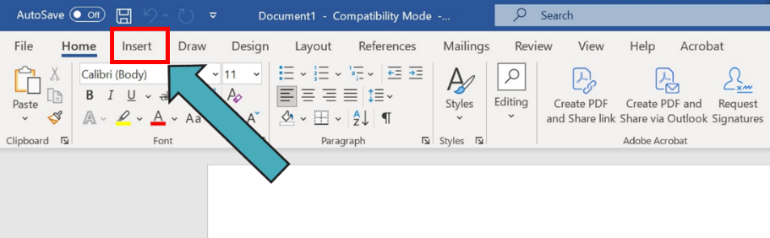

Shapes Tool
In the Illustrations area, click on the Shapes Tool to display a dropdown menu of shapes that can be inserted into your drawing space (blank document).
Keystrokes: S H
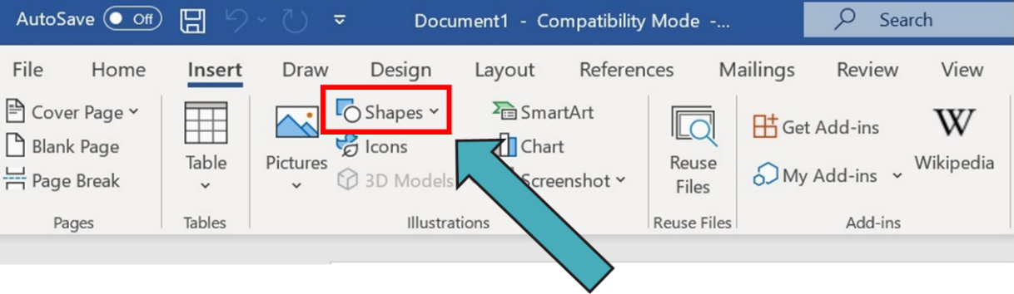
There are several categories and many choices in the shapes tool: Recently used shapes, lines, basic shapes, block arrows, flowchart symbols, callout symbols, and stars/banners. Click on the shape you want.
Keystrokes: Use the arrow keys to navigate and press Enter on the shape you want.
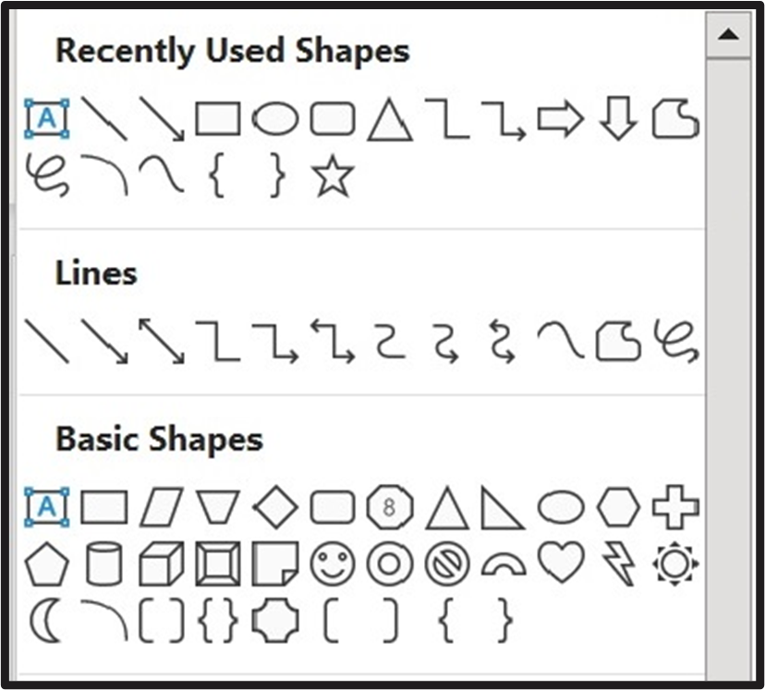

Click inside your drawing space to add the shape.
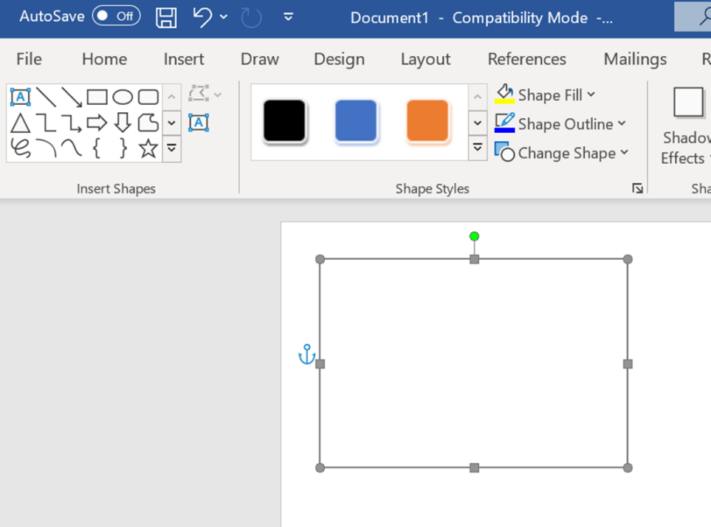
Tips for manipulating shape size and location:
- Click and drag on a corner or edge of the shape to change its size and appearance
  - A two-headed arrow appears when the mouse hovers over one of the small corner circles or mid-edge squares on the shape, allowing you to adjust it
- To maintain the element’s proportions, hold the Shift key as you click and drag
- If you are using the keyboard, press ALT + JD (Shapes Format tool), then H for Height or W for Width and use the up/down arrows to make size adjustments
- To change an element’s location:
  - Click and drag it to the desired position
  - OR click on it and release, then use arrow keys to move it around
    - This allows for finer location/position adjustments

Shape Format Tab
If you click on any shape in your drawing space, a Shape Format ribbon will appear at top right inside the Word window. Click on Shape Format to open a new menu of drawing options.
Keystroke: ALT + J D
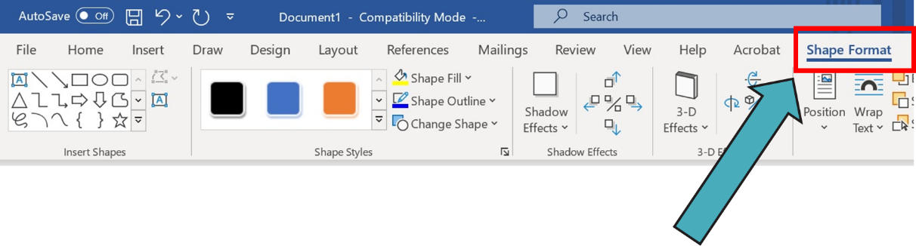

Shape Styles
The Shape Styles area includes three dropdown menus: Shape Fill, Shape Outline, and Change Shape.
Keystrokes: Inside the Shape Format ribbon, press S F for Shape Fill; S O for Shape Outline; and I for Change Shape (???).
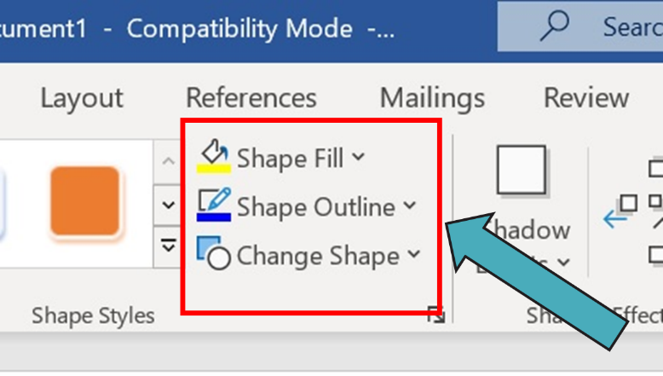

Shape Styles: Shape Fill
Click on Shape Fill to open a dropdown menu of color and other fill choices.
Keystrokes: Inside the Shape Format ribbon, press S F, then arrow keys to navigate, then Enter to confirm your choice.
Tip: Use only black or gray fills. Color fill results may not be consistent on the Monarch or display as they do with embossed graphics.
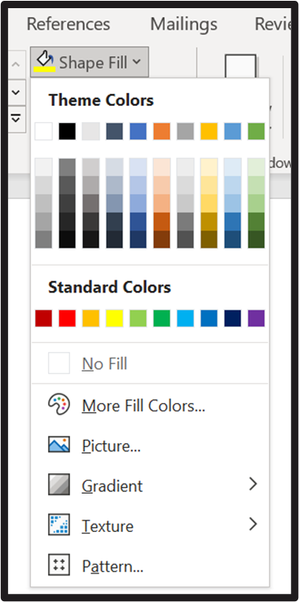

Shape Fill → Pattern Fill
Inside the Shape Fill dropdown menu, click on Pattern Fill to open a dropdown of pattern fill options.
Keystrokes: In the Shape Fill dropdown, press A, then Tab, then use arrow keys to navigate, then press Enter to confirm your choice.
Tip: Some pattern fills produce better results than others.
- Textures with fine detail may not show up properly or at all
- The larger the details of a texture, the better it will look on the Monarch
- Good:
  - Horizontal, vertical, and diagonal lines spaced at least 3/16” apart
  - “Brick” patterns
  - Checkerboards with ¼-inch squares
- Some experimentation will be necessary to find the right patterns for your graphics
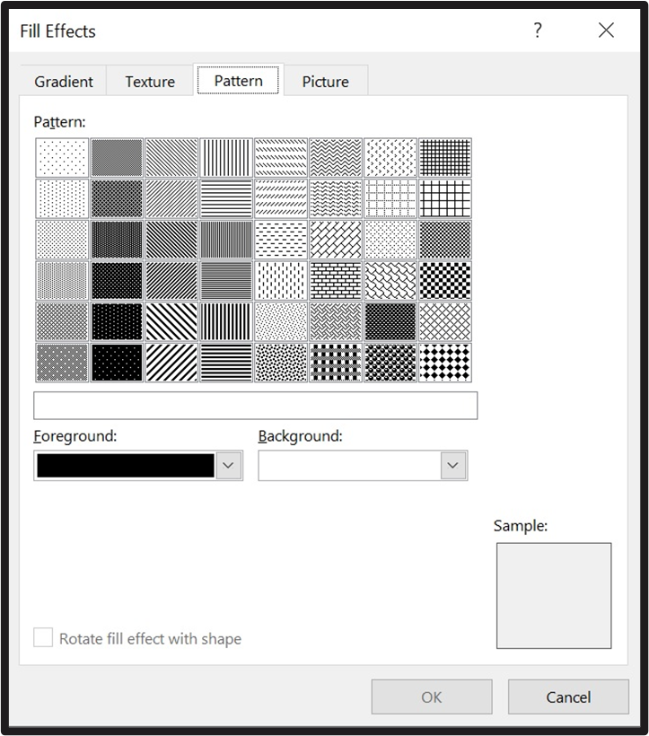

Shape Outline → Weight
Click on Shape Outline, then Weight, to open a dropdown menu of line thickness choices.
Keystrokes: Inside the Shape Format ribbon, press S O, then W, then Down arrow, then Enter to confirm your choice.
Tips for choosing line weights:
- Use only black lines
- 1-point weight creates accurate 1-dot lines, but some lines in a multi-line shape may be missing or incomplete
- 6-point weight consistently creates accurate 1-dot lines in a multi-line shape
- 12-point weight consistently creates accurate 2-dot lines
- Dashed and dotted lines can be used for contrast, but it will be necessary to experiment to find the weight(s) that are best for the graphic you are creating
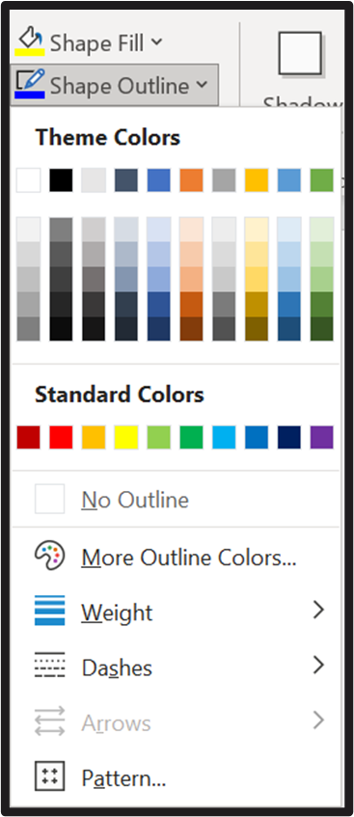

Shape Height and Width
At far right, inside the Shape Format ribbon, there are dropdown menus where you can choose a specific height or width for your shape.
Keystrokes: Inside the Shape Format ribbon, press H for Height and W for Width.
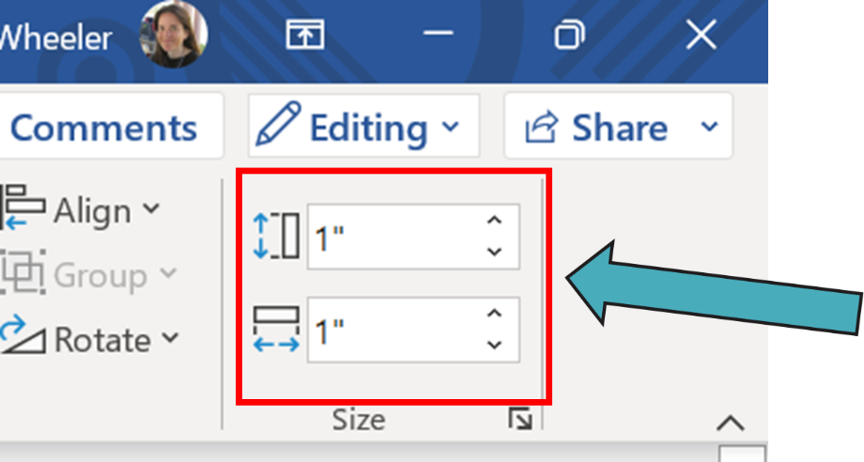

Arrows
Arrows are in the Shapes tool (Insert ribbon).
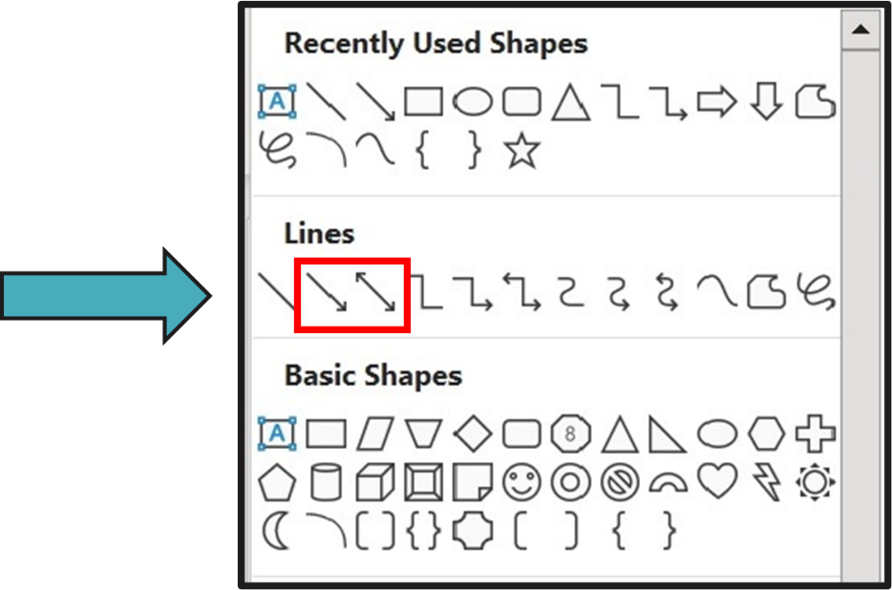

Additional options for drawing with arrows:
You can also add an arrowhead to a line that you have already created.
- Right-click on the line
- Click “Format Autoshape/Picture” or “Format Shape”
- In the “Lines” or “Colors and Lines” area, look for an “Arrows” category
- Choose either “Begin style” or “End style” (depending on which end of the line you want to alter) or both for a two-headed arrow
- Choose the arrowhead and the size that you want
  - As big as possible for both is best
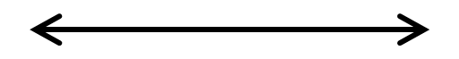

Icons
To add an icon (prefabricated shape), click on the Insert ribbon.
Keystroke: ALT + N
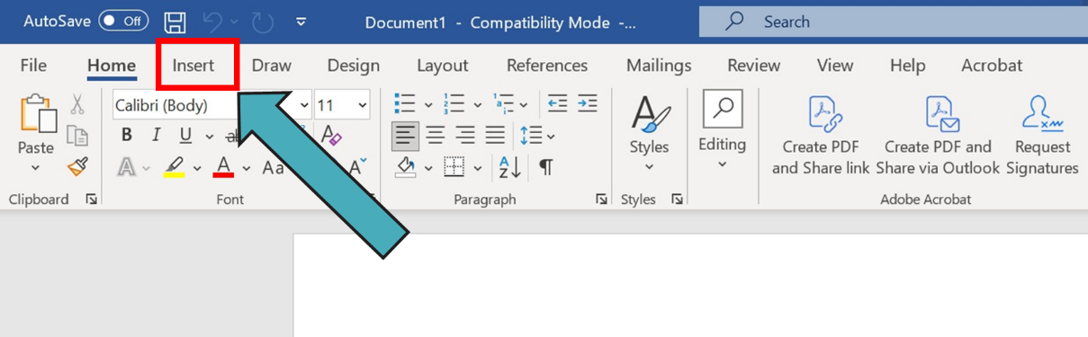
Inside the Illustrations area, click on the Pictures dropdown menu.
Keystroke: P
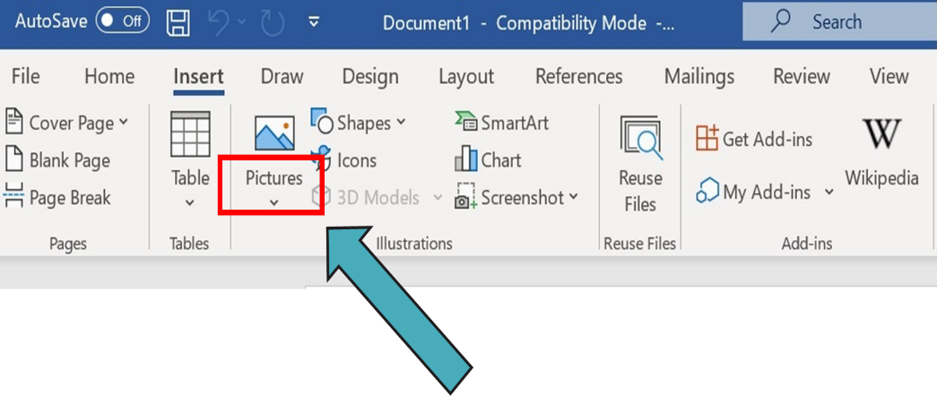
Inside the Pictures dropdown menu, click on Stock Images.
Keystroke: S
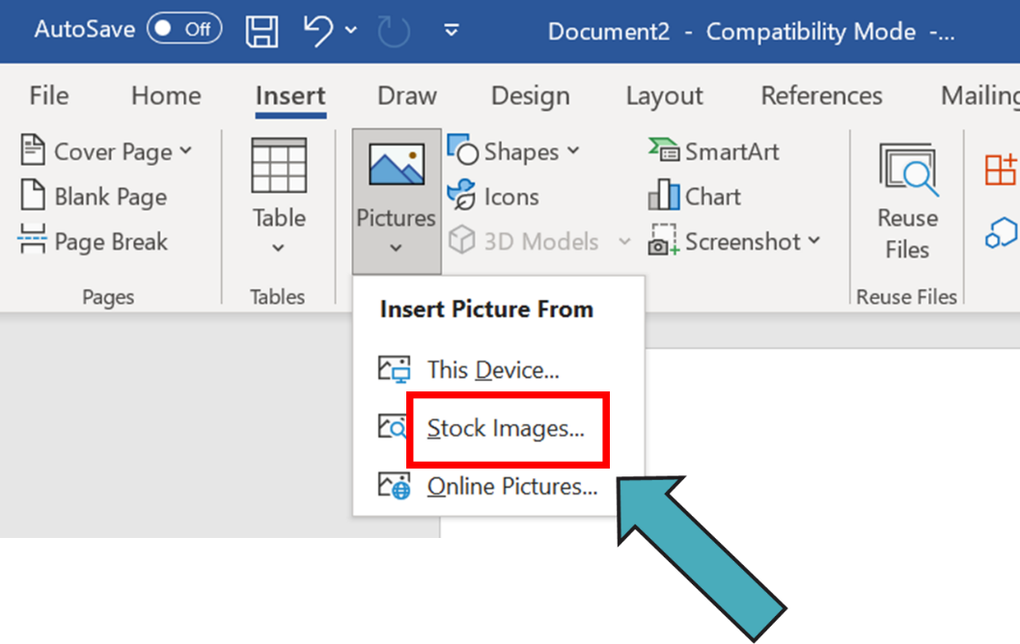
Click on Icons, then type a search item and press Enter.
Keystrokes: Shift Tab to Images → Arrow right to Icons → Enter → Tab to edit field → Type search text → Enter → Tab to the icon you want → Enter → Tab to Insert → Enter
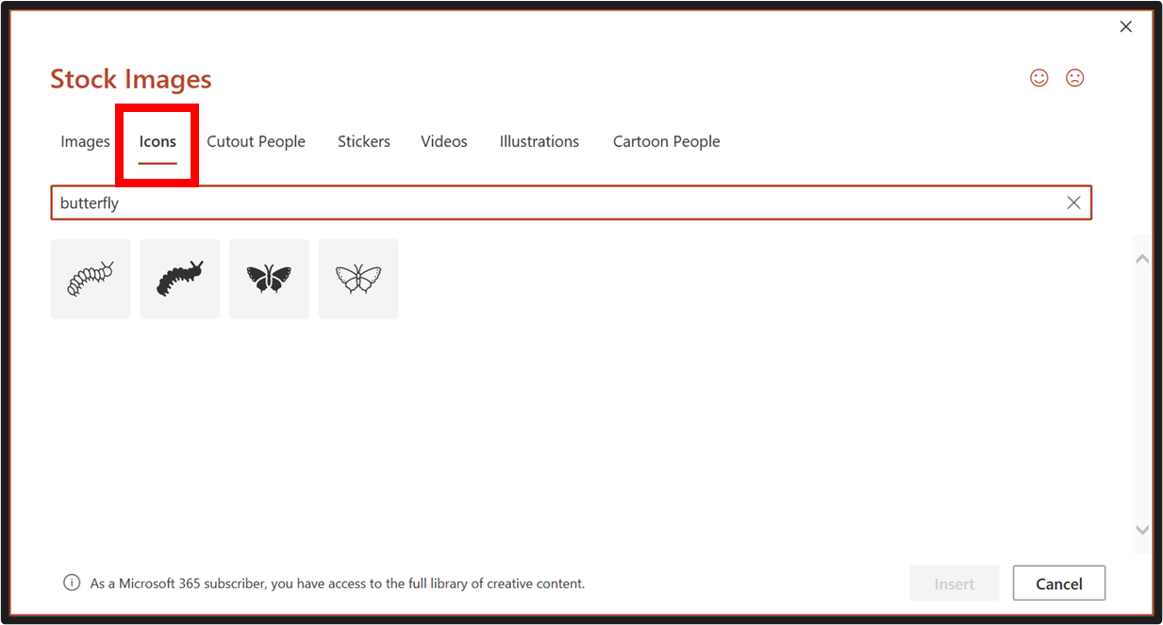

Comments Regarding the Use of Icons and Other Prefabricated Images
- The full list of choices in stock images includes Images, Icons, Cutout People, Stickers, Videos, Illustrations, Cartoon People
- Not all these choices or the pictures within them will be relevant to the Monarch
- Some experimentation with prefabricated drawings and their line weights will be necessary to understand design aspects that work well on the Monarch

Other Types of Images
You can insert other types of images, including photographs, in several ways:
- Insert ribbon → Pictures → Online Pictures → Type search text
- Insert ribbon → Pictures → Stock Images → Images → Type search text
- Save an image from an internet search → Insert ribbon → Pictures → This device
These kinds of images will not work well on the Monarch. However, you can trace over the images to create your own drawings:
- Use the free form tool in Word Draw and other shapes that fit each image's requirements
- For free form, if you have a touch screen, use your finger or a stylus; if you do not have a touch screen, use a real mouse
- Simplify as necessary so that only the essential information in the image that is needed for educational purposes is conveyed
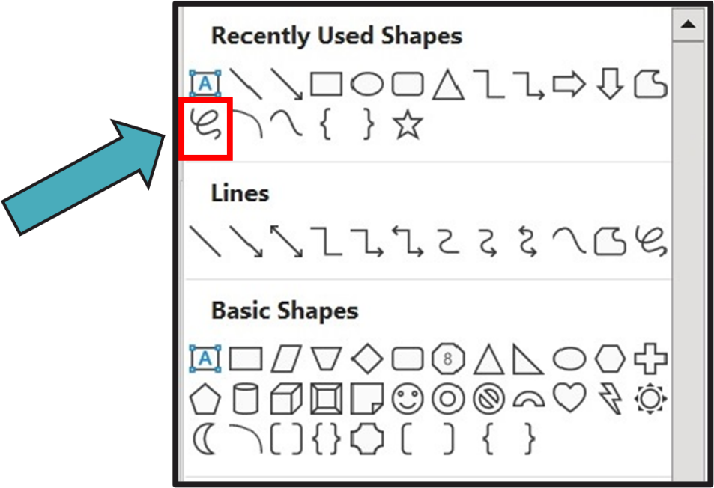

Text Wrapping
If an icon or other image that you insert will not move easily:
- Right-click on the picture
- Click on "Wrap Text," then click on "In front of text"
- OR click on "Size and position"
- Click on "Text wrapping"
- Click on "In front of text"
- Click OK
Different versions of Word might have different processes for this, but the basic idea is that you need to free the image from its position in the text.

Grouping Objects
Grouping objects makes it easier to move them around:
- Hold down the Shift key and click on the outline or outer boundary of every shape and text box that you want to include in the group
- Right-click on one of the shape boundaries
  - Make sure that you see the four-headed arrow before you right-click or you will have to start over
- Click on "Group," then click on "Group" again
- Now you can move all your items together
- You can "ungroup" using the same process
- You can also move items together without grouping them by holding Shift, clicking on each item you want to move, and then dragging them together to the place you want them to go

Using the MS Word Graphic Template
The MS Word Graphic Template file that accompanies this guide is specially designed as an 11x11½-inch drawing space to fit the Monarch and your tactile graphic design needs. You can make the visual space of the template smaller if that helps you to see more of the whole graphic space while working in Word.
- Click on the View ribbon
- Click Zoom
- Choose 75%, or enter a percentage that you like

Make sure you save a copy of the original template!
- Each time you create a new graphic using the template, go to the File ribbon
- Click "Save as"
- Give your file a new name and save it in another location where you keep your graphics

Blank Space
When two graphic elements cross lines, it is helpful for the reader either to make one of them a different weight/texture, or to add a little blank space where they cross.
For blank space:
- Create a square with an outline that can be used as a blank space template
- Add a white fill to the square and save it in a file where you keep template shapes that you have made
- When needed, copy/paste the square in your document and place it on the element that will go "behind" the other
- Remove the outline around the square
- Place the element that goes on "in front" over the square, where the two elements will cross
- Right-click on the "behind" element, click on "Send to Back," then click on "Send to Back" again
- Right-click on the "in front" element, click on "Bring to Front," then click on "Bring to Front" again

Elements That Cross: Examples
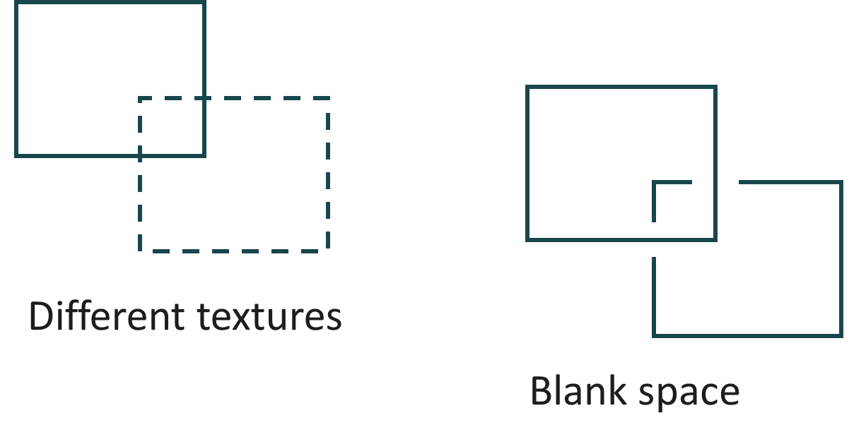

Braille Labels
Braille labels are an essential element of many tactile graphic displays for students. The following steps and guidelines will assist you with creating and placing your braille labels, in both uncontracted and contracted formats.

Braille Labels: Uncontracted
If your labels are uncontracted:
- You can use the letters on the keyboard to type your text
- For a capital sign, use the comma (QWERTY equivalent for dot 6)
- For numbers, press the crosshatch key # (Shift + 3) and then press the letter that corresponds to each number
  - Examples: For the number 5, press the crosshatch and then E; for the number 18, press the crosshatch, then A, then H
  - Don’t use keys on the number row or numpad to create literary numbers! That will give you dropped (Nemeth-style) numbers.
- For the period, press 4 on the number row/numpad (QWERTY equivalent for dots 2-5-6)
- For the exclamation mark, press 6 on the number row/numpad (QWERTY equivalent for dots 2-3-5)
- For the question mark, press 8 on the number row/numpad (QWERTY equivalent for dots 2-3-6)
- For any additional punctuation, see Guidelines and Standards for Tactile Graphics 2022, Appendix A, “Braille to ASCII Conversion”

Braille Labels: Contracted
If your labels are contracted:
- The computer language “ASCII” assigns each of the letter, number, and print signs on the keyboard one symbol that corresponds to a braille character
- Refer to the file Guidelines and Standards for Tactile Graphics 2022, Appendix A, “Braille to ASCII Conversion” for these keyboard equivalents
- Each of the contractions and punctuation signs has an equivalent that is represented in this chart

ASCII Examples
Jenny
- ASCII: ,j5ny
- Braille: ,j5ny
- Comma = capital sign
- 5 = “en” contraction
Frodo Baggins
- ASCII: ,frodo ,ba79s
- Braille: ,frodo ,ba79s
- Comma = capital sign (twice)
- 7 = “gg” contraction
- 9 = “in” contraction
The cat and the dog are friends.
- ASCII: ,! cat & ! dog >e frs4
- Braille: ,! cat & ! dog >e frs4
- Comma = capital sign
- ! = “the” contraction (twice)
- & = “and” contraction
- > = “ar” contraction
- frs = shortform for friends
- 4 = period
I like Mount Rushmore! Do you?
- ASCII: ,i l ,m.t ,ru%more6 ,d y8
- Braille: ,i l ,m.t ,ru%more6 ,d y8
- Comma = capital sign (four times)
- L = “like” contraction
- . (period) = dots 4-6
- .t = dots 4-6, t = “ount” contraction
- % = “sh” contraction
- 6 = exclamation mark
- D = “do” contraction
- Y = “you” contraction
- 8 = question mark

Using the Apostrophe and Quote Keys
Tips to ensure that all the keys on your keyboard respond to ASCII commands:
- Dot 3 is created using the Apostrophe key, and Dot 5 is created using the double quotes (Shift + Apostrophe)
- To make these available for braille use, turn off the Autocorrect function that changes their print appearance
  - Click on the File ribbon in Word
  - Click "More"
  - Click "Options"
  - Click "Proofing," then click "Autocorrect Options"
  - Uncheck the box that replaces "Straight quotes" with "smart quotes"
  - Click OK, then click OK again

Creating Text Boxes for Braille Labels
Click on the Insert ribbon to display a basic menu of drawing options.
Keystroke: ALT + N
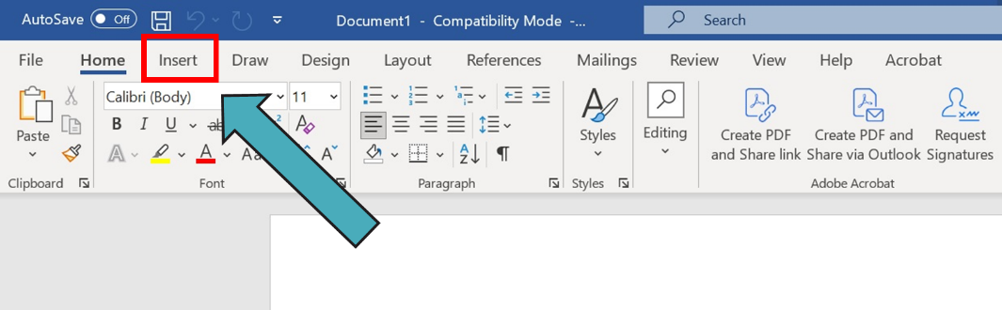
In the “Text” area, click on the Text Box dropdown menu.
Keystroke: X
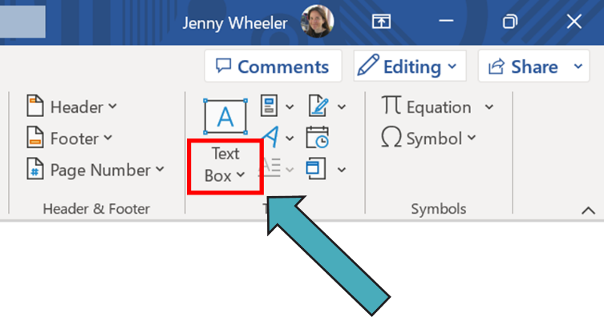
Click on Simple Text Box.
Keystroke: Enter (the focus is already on Simple Text Box)
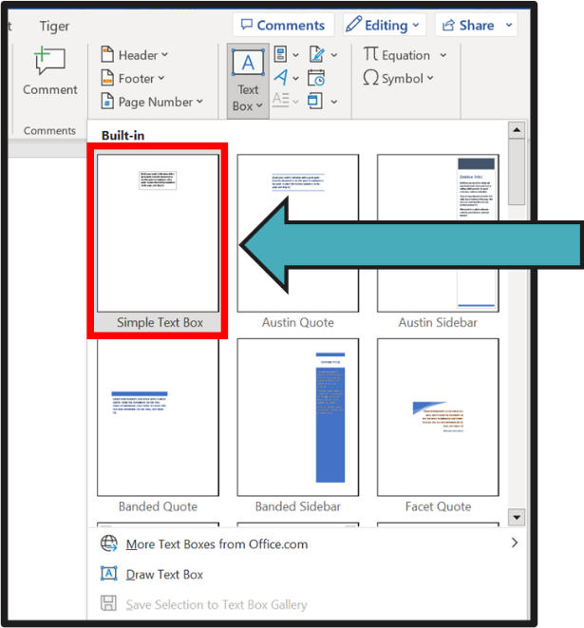
Steps for utilizing text boxes:
- Change the text in the box to Braille29
- Change the font size to 29-point
- Type your text in uncontracted or contracted braille
  - Use the ASCII chart as needed for contracted braille
- Enlarge or shrink your box as appropriate to fit your text
- Right-click on the print outline of the box
- Click "Format Autoshape/Picture" or "Format Shape"
- Under "Line," click "No color" or "No line" or whatever your version of Word requires to eliminate the outline
- Text boxes can be moved around a page to suit your needs
- Save a text box that you have created with 2-3 braille characters in it as a template so that you can simply copy and paste it into a graphic document and quickly make necessary text changes

Text Boxes with White Fill
Sometimes a label needs to go on top of a graphic element, and therefore needs to have pre-designed blank space (a kind of “halo”) around it. Example: A number label on a graph with grid lines.
To create this blank space around the text box:
- Right-click on the outer edges of the text box, where the outline would be
  - Note: Don't click inside the box where the text is, but on the outside of the box
- Click on "Format Autoshape/Picture" or "Format Shape"
- Under Fill, there is a color box
- Click on “White” to create a white fill inside the box
- Right-click on the outside of the box again
- Click on "Order," then click on "Bring to front" to ensure that your text box takes priority over the graphic elements it is on top of
- Place your label inside the graphic where you want it to go

Hints for Using ASCII in Braille Labels
- It is good idea to create a braille label template that you can adjust as necessary. A label template is a text box that contains one or two braille characters in Braille29 font and can be easily copied and pasted into a document for quick manipulation (see above, Steps for Utilizing Text Boxes).
- Most punctuation symbols are rendered using the numbers on the number row or Numpad
  - 1 = literary comma, 2 = semicolon, 3 = colon, 4 = period, 6 = exclamation mark, 8 = question mark, 9 = Nemeth opening parenthesis, 0 = Nemeth closing parenthesis
  - The exceptions are the apostrophe, forward slash, and backslash, which are all created using their respective keys on the QWERTY keyboard

Braille Text Copied from a Translation Program
Sometimes you may need to have more than a simple label in a graphic (i.e., a full sentence or paragraph of text). If you are very comfortable with ASCII, you can simply type this text into the file. However, this is time-consuming, and it is a good idea to have a braille translation program open while you create a graphic to which you need to add a lot of braille text. Free translation programs include BrailleBlaster and Perky Duck, and popular commercial translation programs include Duxbury and Braille2000. Braille text can go before or after the graphic in the Word file, depending on its explanatory purpose. The following steps will guide you through creating and inserting this text.

In your Word graphic file:
- Click on the line where you want to insert your text
- Make sure that your cursor is located at the leftmost point on the line (fully left-adjusted)

In your braille file:
- Braille the text that you want to insert
- Use contracted or uncontracted braille, depending on your student’s needs
- Highlight and copy the text

In your Word graphic file:
- Paste the text
- Highlight the pasted text and change the font to Braille29
- Change the font size to 29-point
- Click at the beginning of the first line of braille text, and backspace so that the text is left-adjusted on the line (if needed)
- If you want to indent this line, press space two times to move the beginning of text to cell 3
- Use the Enter key and spacebar to create any other formatting that you need (i.e., indented list format)
- Hint: Don't use the first line of the Word graphics document to paste your text
  - You might lose your template formatting
  - Instead, paste on the second line and then move your text up to the first line

Saving Your Graphic Document
The Monarch’s Tactile Viewer will accept files saved in the following formats:
- PDF
- JPG
- PNG
PDF files appear in the Tactile Viewer with two Zoom levels, while JPG and PNG appear with multiple Zoom levels.

To save a Word file as a PDF file:
- Open the File ribbon
- Choose Save As
- Enter your file name
- Click on/activate “More Options”
- In the “Save as type” dropdown menu, choose PDF
- Choose “Save”
If you prefer a JPG or PNG file format, you can use a program like Adobe Illustrator or an online “PDF to JPG” or “PDF to PNG” converter to save your PDF file in one of these alternative formats.

Guidelines and Standards for Tactile Graphics
The Guidelines and Standards for Tactile Graphics 2022 is a document sponsored and published by the Braille Authority of North America. It was not strictly conceived for electronic tactile graphics; many of its examples were created using other methods (collage, mixed, microcapsule, vacuum-formed, tooled with paper or aluminum foil, etc.). However, these guidelines are invaluable for transcribers and tactile graphic artists, and understanding a few of their design principles will assist you as you create Monarch graphics for your students.

Elements in Graphics
- Area: Significant region in a graphic
  - States or provinces in a map, stripes of different colors in a flag, layers of soil or rock in a classification diagram
- Line: Linear information
  - Rivers, geographic boundaries, historical routes, pathways in an electrical circuit, outline of a shape, parts of an angle, length to be measured
- Point: Specific place on a graphic
  - Location of a city, bus stop, oil well, point in a line graph, gland in an anatomy diagram
- Label: Words or alphabetic or numeric key used to identify an area, line, or point symbol
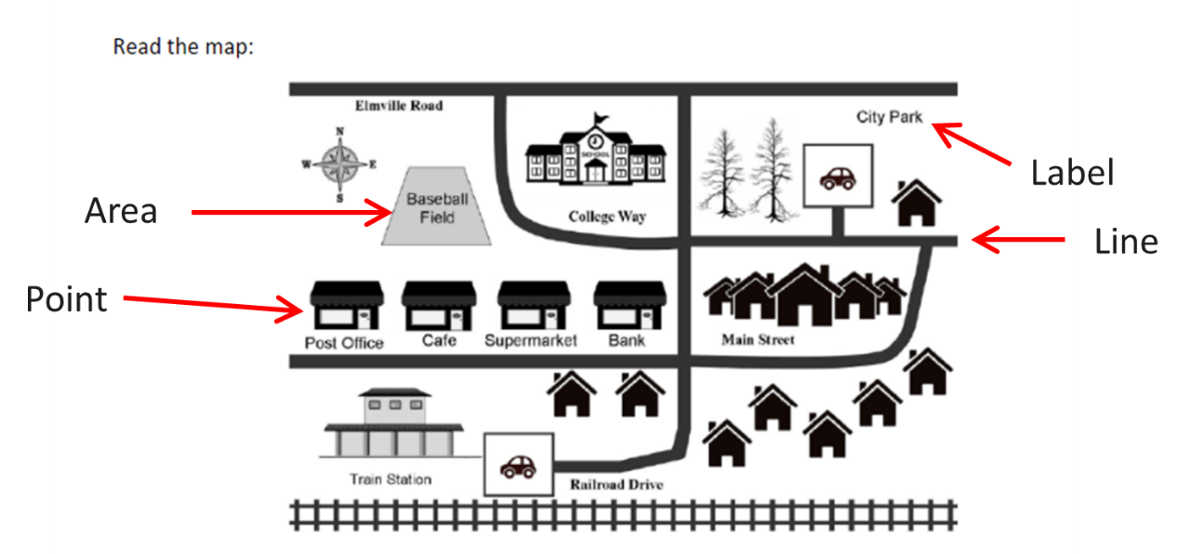

Basic Design Principles
Most often, tactile graphics are not exact replicas of the print. They are representations of material rather than strict reproduction. Some important considerations:
- Identify the content that needs to be included
  - What are the key components you will be reproducing and how do you want to create them?
  - Areas, lines, points, and labels (including necessary keys or legends)
- Eliminate unnecessary parts
  - As a general rule, automatically omit anything that is decorative
  - For complicated graphics, determine what is needed to convey meaning and what is extraneous
- Simplify as much as possible
  - Many print graphics can be altered effectively to better fit a tactile format without altering the meaning
  - Example: Simple shapes can be used for counting purposes in mathematical diagrams rather than more complex print images
- Separate a cluttered, complicated image that needs to retain most of its parts into multiple graphics for better discrimination and understanding
- 3-D print images can be rendered in 2-D tactile graphic form with an explanation to the reader
- Be consistent with your use of symbols and keys
- Place the graphic at the left margin of the page
- Include a blank line before and after the graphic
- Make your graphics as small as makes sense for its requirements and your student’s needs, while still leaving enough space around and inside them for exploration and recognition
  - Especially when small hands are looking at them!
- Avoid clutter
- Keep your delineations between elements (lines, areas, point, etc.) as clean and discriminatory as possible
  - The center of your fingertip should fit between any two graphic elements so that you can feel a small but clear distance between them
  - Use blank space or different line textures to distinguish overlapping elements
- Don't put your labels too close to or too far away from the elements they identify
  - Labels need to be at least ¼-inch away from any graphic element
  - The same “center of your fingertip” rule applies here

Keys
A key is a list of symbols that appear in a tactile graphic. Symbols may be pictorial (i.e., point symbols like dots, stars, triangles, etc.) or textual (braille labels). Some basic principles for keys include:
- If a text label consists of a word or a short phrase/mathematical expression that will easily fit within the graphic space, include the full label
- If a text label is too large for the graphic space, use a symbol (pictorial or textual) to represent it, then explain the use of the symbol in a key
- A textual symbol can be alphabetic or numeric
- For an alphabetic symbol, choose 2 or 3 braille symbols that represent the label
  - Contractions, including shortforms, may be used (except in Nemeth)
  - At least one of the symbols needs to have a bottom dot (dot 3 or dot 6)
  - 2 symbols are better than 3 symbols whenever possible
- If you use a single braille character as a symbol to represent a label (not preferred):
  - Include a grade 1 indicator before an uncapitalized letter
  - No grade 1 indicator needed before a capitalized letter
- For a numeric symbol:
  - Use a number sign
  - No period after the number
  - All numeric labels use numbers in the upper part of the cell, even in Nemeth
- In your key, list all the symbols and their interpretations
- A key should be placed before the graphic on the same page, if possible
- If the key will not fit on the same page as the graphic:
  - Place a one-page key on a facing page to the left of the graphic
  - Place a multiple-page key on the pages that follow the graphic (to the right)
- List key symbols in this order:
  - Area textures
  - Line textures
  - Point symbols
  - Alphabetic text symbols
  - Numeric text symbols
- Symbols within these categories do not need to be listed in alphabetic order
- Choose an order that makes sense for the graphic (i.e., most significant elements to least significant)
- Example of a graphic key from Guidelines and Standards for Tactile Graphics 2022, page 5-39:
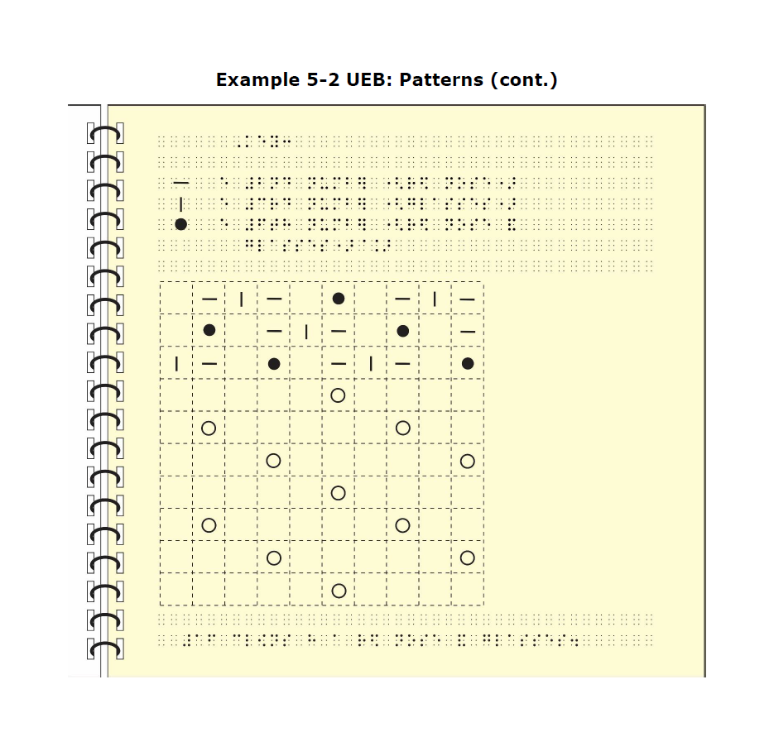
Image Description: The tactile diagram has a 10 by 10 square grid. Some squares in the grid include a symbol - a short horizontal line, a short vertical line, a hollow circle, or a solid circle. A key identifies the meaning of three of the pictorial symbols used in the graphic: short horizontal lines = 2nd number (red nose), short vertical lines represent 3rd number (glasses), and solid circles represent 6th number (red nose and glasses). The meaning of the hollow circles is not listed in the key.

Conclusion
We hope this guide has provided you with the information and steps needed to confidently create graphics for your students using Word with the Monarch. We welcome your feedback and questions! Please contact us at outreach@aph.org.

